**Algebra 1-Thanksgiving Worksheet**

Name:______________________________ Period:_______

Solve the following equations to find out how many of each ingredient you are to receive. Solve #1 using graphing and #2 using substitution. **Be sure to show all of your work!!!**

1. 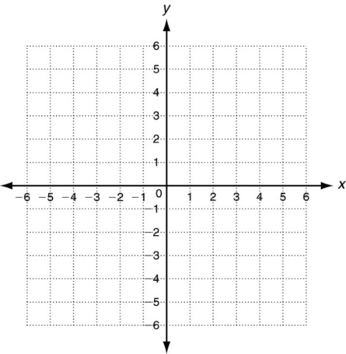In order to decorate the turkey, you need a certain number of cookies (for the body) and semi-sweet chocolate chips (for the head and feet). If you know that the number of semi-sweet chocolate chips is two times the number of cookies plus one, and that two times the number of cookies and two times the number of semi-sweet chocolate chips is eight, how many of each do you need? (be sure to define your variables)
2. You also need a certain number of candy corn (for feathers) and kisses (for the body). If you know that two times the number of kisses plus four times the number of candy corn is thirty, and the number of kisses is four times the number of candy corn minus twenty-seven, how many kisses and candy corn do you need? (be sure to define your variables)
3. The last item that you need is a red candy (for the gobble). The number of gobbles needed can be found by solving x – 4 = 3x – 6. (x = the number of gobbles needed)