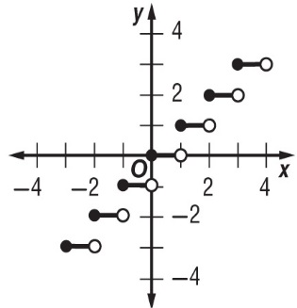
Step Function Practice Name:
f(x) = $⟦x⟧$ Date: Period:

Graph each function
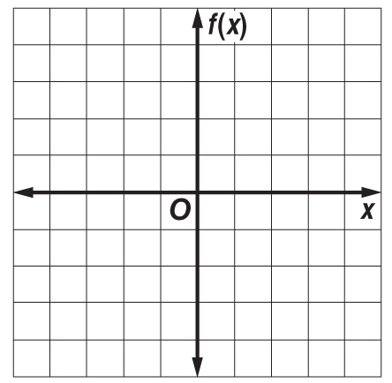
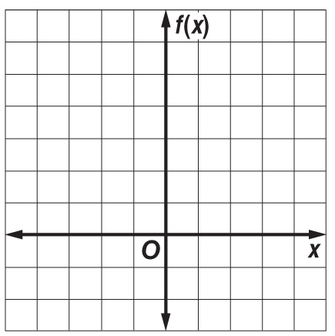
1. f(x) = 2$⟦x⟧$ 2. f(x) = $⟦x⟧$ + 4

3. BUSINESS A Stitch in Time charges $40 per hour or any fraction thereof for labor. Draw a graph of the step function that represents this situation.
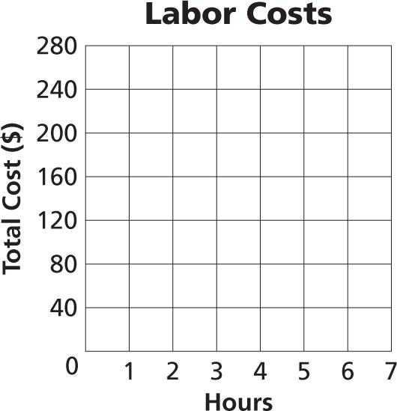
a) How much would A Stitch in Time charge for 3 hours?

b) How much would A Stitch in Time charge for 5 hours and 20 minutes?

4. SAVINGS Nathan puts $200 into a checking account as soon as he gets his paycheck. The value of his checking account is modeled by the formula 200$⟦m⟧$, where m is the number of months that Nathan has been working. After 105 days, how much money is in the account?

