Graph each function. Then find f(-1), f(0), and f(3).
1. f(x) = $\left\{\begin{aligned}-1 if x≤0 \\ 2x if 0<x≤ 3 \\ 6 if x>3\end{aligned}\right.$ 2. f(x) = $\left\{\begin{aligned}-x if x<-1 \\ 0 if -1≤x≤ 1 \\ x if x>1\end{aligned}\right.$
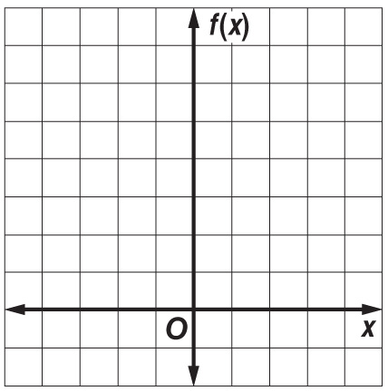
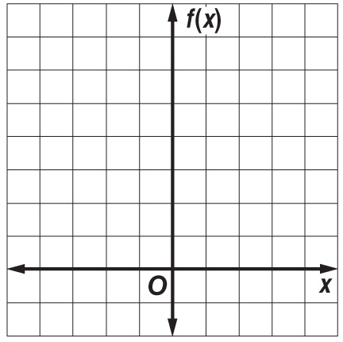

3. f(x) = $\left\{\begin{aligned}x if x<0 \\ 2 if x≥0\end{aligned}\right.$ 4. h(x) = $\left\{\begin{aligned}3 if x<-1 \\ x+1 if x>1\end{aligned}\right.$
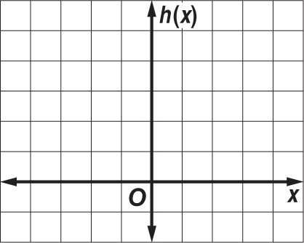
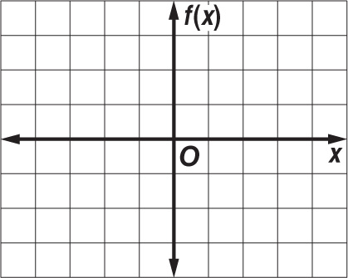

Graph each function. Then find f(-1), f(0), and f(3).
1. f(x) = $\left\{\begin{aligned}-1 if x≤0 \\ 2x if 0<x≤ 3 \\ 6 if x>3\end{aligned}\right.$ 2. f(x) = $\left\{\begin{aligned}-x if x<-1 \\ 0 if -1≤x≤ 1 \\ x if x>1\end{aligned}\right.$

3. f(x) = $\left\{\begin{aligned}x if x<0 \\ 2 if x≥0\end{aligned}\right.$ 4. h(x) = $\left\{\begin{aligned}3 if x<-1 \\ x+1 if x>1\end{aligned}\right.$

