Parent Function Graphic Organizer
What is a parent function?
Name | Parent Function Equation | Graph | Domain & Range | Key Characteristics* | Table of Values
Constant |  | 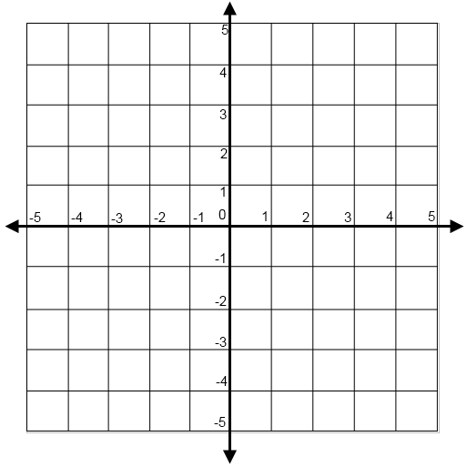 |  |  | x f(x)
Linear (stop at 1:55) |  |  |  |  | x f(x)
Quadratic |  |  |  |  | x f(x)

Name | Parent Function Equation | Graph | Domain & Range | Key Characteristics* | Table of Values
Cubic |  |  |  |  | x f(x)
Square Root |  |  |  |  | x f(x)
Cube Root |  |  |  |  | x f(x)
Absolute Value (stop at 1:45) |  |  |  |  | x f(x)
Name | Parent Function Equation | Graph | Domain & Range | Key Characteristics* | Table of Values
Exponential  (growth) |  |  |  |  | x f(x)
Exponential  (decay) |  |  |  |  | x f(x)
Reciprocal |  |  |  |  | x f(x)
*Key characteristics refers to intervals where the function is increasing or decreasing, constant, positive, or negative. It also refers to relative maximums and minimums, symmetries, and end behavior.

