**C:\Program Files\Microsoft Office\MEDIA\CAGCAT10\j0212661.wmfLinear Functions**

**REVIEW**

**Select the best answer.**

1. Which graph represents a linear function?

A 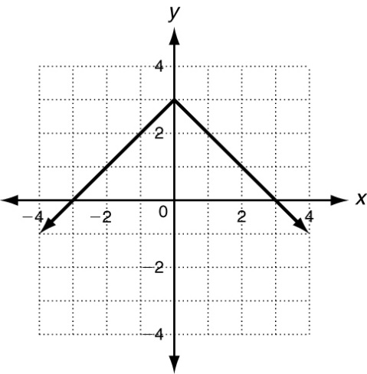

B 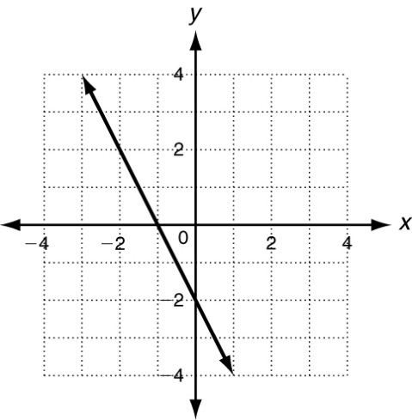

2. A car travels at 30 mi/h. The function  
*f*(*x*)  30*x* gives the distance the car travels in *x* hours. What is the **domain** of this function? *think if this should be discrete or continuous

3. Find the *x*-intercept of the equation  
*7x*  3*y*  21.

4. The table shows the price of a video game for different years since the game was released. **Find the rate of change during each time interval** and determine during which time interval did the price **decrease** at the greatest rate?

|  |  |  |  |  |  |
| --- | --- | --- | --- | --- | --- |
| **Year** | 2000 | 2002 | 2003 | 2005 | 2007 |
| **Price ($)** | 50 | 57 | 52 | 55 | 43 |

5. The slope of this line is ___________.



6. Find the slope of the line that contains the points (-5, 7) and (5, 2).

7. What is the slope and *y*-intercept of the graph?

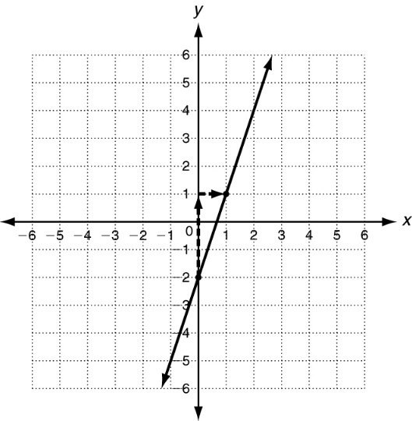

8. Write an equation that in slope-intercept form that describes the line with a slope of  that contains the point (4, -2)?

9. Which equation describes the line with a slope of -2 and *y*-intercept of 10?

10. Is this relationship a direct variation?

y = 4x + 3

A yes B no

11. Find the x- and y-intercepts of

5x  2y  20. Write the answers as points.

x-intercept:

y-intercept:

12. A jogger runs 8 mi/h. The f(x)  8x gives the distance the jogger travels in x hours. **Graph this function**.

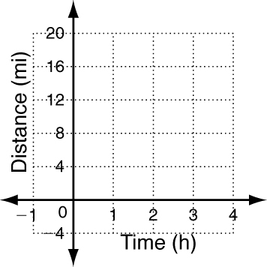



**Give its domain and range**.

Domain:

Range:

13. Tell whether the slope of this line is positive, negative, zero, or undefined.

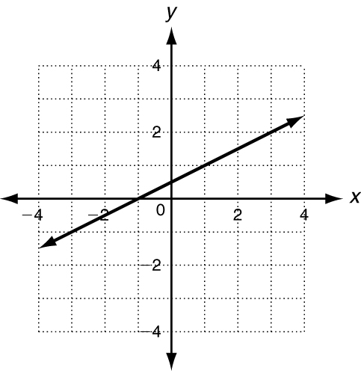

14. Over the last 85 years, the average temperature has decreased by 5 degrees worldwide (I made this up). What is the rate of change in worldwide temperature per year?

15. A climber is on a hike. After 2 hours he is at an altitude of 400 feet. After 6 hours, he is at an altitude of 700 feet.

a. What is the hiker’s rate of change in feet per hour and feet per second?

b. Write a linear equation in slope-intercept for to represent the hiker’s situation.

c. What is the y-intercept and what does it represent?

16. Write an equation in slope-intercept form that describes the line with a slope of 5 and y-intercept of -8.

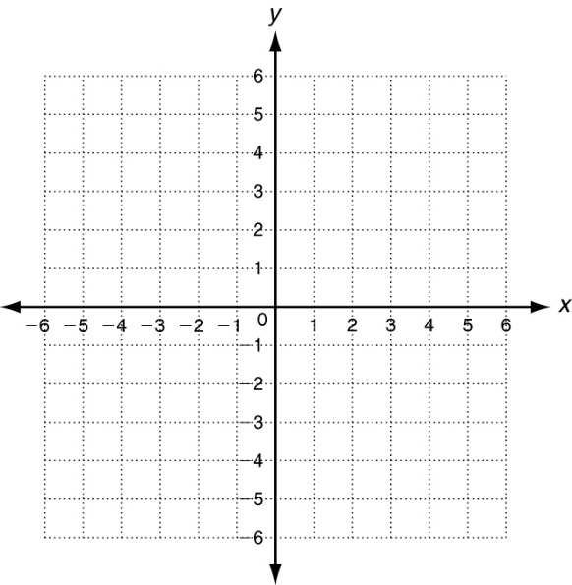 17. Graph the line with a slope of - and y-intercept of 5.

18. Tom is trying to relieve traffic on the main road in his town. His idea is to build a parallel road to the main road. He overlays a grid on the town and determines that the main road’s equation can be represented by y = 2x – 8. The road must go through the point (1, 12) to avoid destroying houses and businesses.

a. Help Tom by finding the equation to the parallel road.

b. The planning commission will save money by doing an expansion while building the road to relieve traffic. Help the commission by finding the equation of a road perpendicular to the main road that goes through (1, 12).