Estimating the Speed of a Tsunami
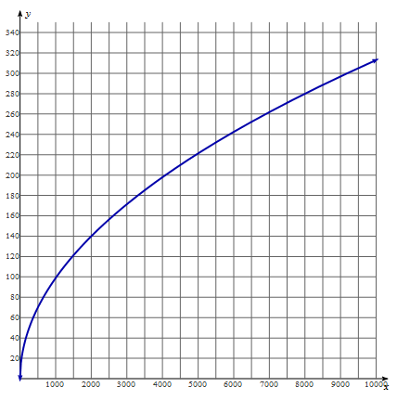

$$S\left(d\right)=\sqrt{9.8d}$$
d = depth of water in meters, S(d) = the speed in meters/second, 9.8 = acceleration due to gravity.
Information has just come in via satellite that a tsunami has been located off Hilo, Hawaii at an ocean depth of 4,500 m.
National authorities are trying to establish how much preparation time these cities will have:
• San Diego, California
• Newport, Oregon
• Kodiak, Alaska
Assignment: Identify how long it will take the tsunami to reach each location. Write a complete explanation of each step you used to identify the solution.

