CP Unit 7 Study Guide: Quadratics, Part 1
For questions 1-6, answer the following questions with an A for always, S for sometimes, or an N for never. Explain your answer.
1. A quadratic function can be solved by factoring.
2. A quadratic function can be solved using the quadratic formula.
3. Solving a quadratic function is the same thing as finding its x-intercepts.
4. Vertex form of a quadratic function is $y=a{(x-h)}^{2}-k$
5. If a < 0, the parabola will open up.
6. The axis of symmetry of a quadratic function is the same as the x-coordinate of the vertex.
Identify the vertex. State whether the parabola is opening up or down.
7. $y=-4{(x+8)}^{2}-10$ 8. $y=\frac{1}{7}{(x-6)}^{2}+12$
vertex: vertex:
up or down: up or down:

Identify the y-intercept. State whether the parabola is opening up or down.
9. $y=7x^{2}-6x+14$ 10. $y=-12x^{2}+7x-19$
y-intercept: y-intercept:
up or down: up or down:

Identify the zeros. State whether the parabola is opening up or down.
11. $y=-2(x+0)(x-12)$ 12. $y=-5(x-4)(x+1)$
zeros: zeros:
up or down: up or down:

Solve by factoring.
13. $x^{2}+11x+30=0$ 14. $3x^{2}+11x=-6$

Determine the roots.
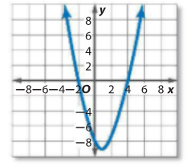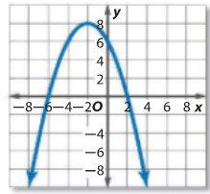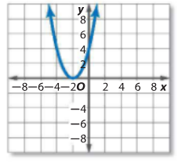
15. 16. 17.

Solve by taking the square root.
18. ${2x}^{2}-128=0$

Solve using the quadratic formula.
19. $x^{2}+6x=-15$

Solve by completing the square.
20. $x^{2}+6x-12=0$

Solve using any method you choose. Explain why you chose the method you chose.
21. $x^{2}-36=0$ 22. $3x^{2}-5x+8=0$

23. Give an example of a quadratic function with a vertex of (-5, 8).

24. Alonso and Aida are solving $x^{2}+8x-20=0$ by completing the square. Is either of them correct? Explain.
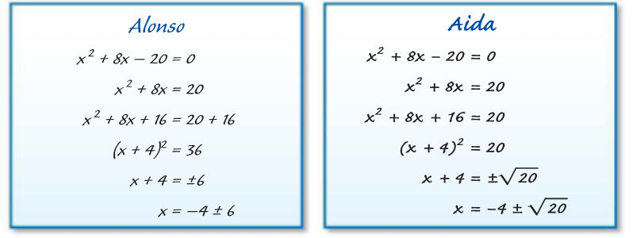
25. Write the equation of a quadratic function with vertex (-1, -25) that goes through the point (-3, -21). Write the function in vertex, factored, and standard form.

26. Describe three different ways to solve $x^{2}-x-20=0$. Which method do you prefer and why? Solve using that method.

27. One of the competitors in a Punkin Chunkin contest launches a pumpkin from the ground. After 4 seconds, it is 256 feet high. The pumpkin lands after 10 seconds. What is the maximum height of the pumpkin? What are the appropriate domain and range for this situation?

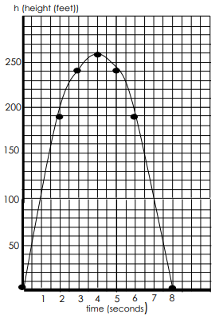
28. The graph at the right shows the height h in feet of a small rocket t seconds after it is launched. The path of the rocket is given by the equation: h(t) = -16t² + 128t.
A. How long is the rocket in the air?

B. What is the greatest height the rocket reaches?

C. About how high is the rocket after 1 second? Is the rocket going up or going down?

D. After 6 seconds, about how high is the rocket? Is the rocket going up or going down?

F. Do you think the rocket is traveling faster from 0 to 1 second or from 3 to 4 seconds? Explain your answer.

